**😊 Dimensionality Reduction**

Dimensionality reduction is a technique used in data analysis and machine learning to reduce the number of input variables or features in a dataset while preserving as much relevant information as possible. It is helpful when dealing with high-dimensional data (data with many features), which can be challenging to analyze due to the "curse of dimensionality." The main goals of dimensionality reduction are to:

1. **Simplify the model**: Fewer features make models less complex and faster to train.
2. **Improve performance**: Reducing noise and irrelevant features can enhance the accuracy of models.
3. **Reduce overfitting**: A smaller feature space helps reduce the risk of overfitting the model to the training data.
4. **Improve visualization**: High-dimensional data is difficult to visualize, so reducing it to two or three dimensions makes it easier to interpret.

There are two main types of dimensionality reduction techniques:

1. **Feature selection**: Selecting a subset of the original features based on their importance. Examples include:
   * Variance thresholding
   * Recursive feature elimination (RFE)
   * Feature importance from models (e.g., using decision trees)
2. **Feature extraction**: Creating new features by transforming the original features into a lower-dimensional space. Examples include:
   * **Principal Component Analysis (PCA)**: A linear transformation that reduces dimensionality by finding the directions (principal components) that maximize variance.
   * **t-SNE (t-distributed Stochastic Neighbor Embedding)**: A non-linear method mainly used for visualization by projecting data into a lower dimension (e.g., 2D or 3D).
   * **Linear Discriminant Analysis (LDA)**: Reduces dimensionality by maximizing class separability for classification tasks.

**😄 To begin with the Lab:**

1. As the number of features in a dataset increases, it becomes harder for a machine learning model to make accurate predictions. Dimensionality reduction helps by reducing the number of features, making the model simpler and improving its ability to generalize.
2. For this lab you need to upload a new file to your EDA Lab folder in Jupyter Notebook with the name wine.csv.
3. After that create a new Python 3 kernel in your Notebook. So, the first thing we need to do is import some important libraries as you can see below then load our CSV file in the notebook as a data frame then read the data from it.

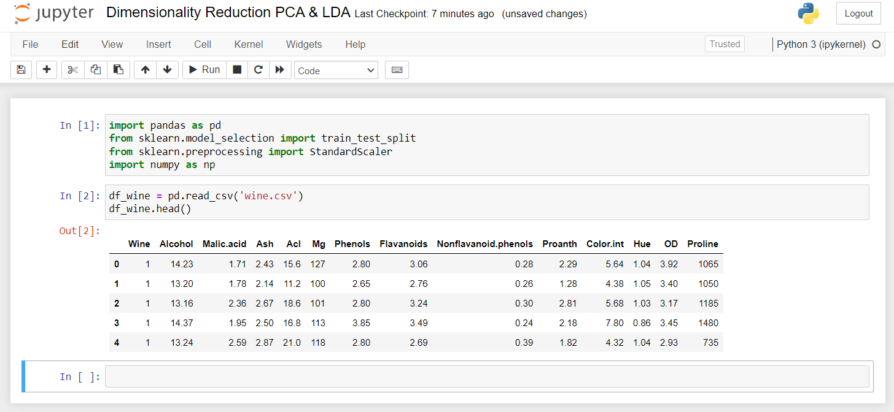

1. Now if we look at the shape of the data frame, we have 178 rows and 14 columns in our dataset.

1. In the commands below we split our dataset into training and testing parts. Then standardize the features so they are all on the same scale. Finally, we calculate the covariance matrix to explore how the features are related.

1. From the commands below we get the eigen values and eigen vectors

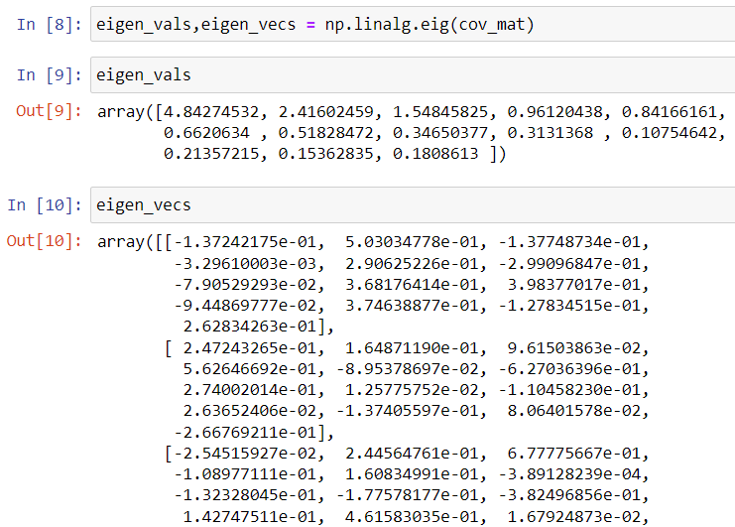

1. This code visualizes the results of **Principal Component Analysis (PCA)**, showing how much variance each principal component explains and how the variance adds up cumulatively across components. It helps you decide how many components you need to capture most of the important information in the data.

1. After breaking down the covariance matrix into its principal components (eigenvalues and eigenvectors), the final step of PCA is to transform the original dataset onto these new principal component axes, reducing the data to its most important features.
2. In this code, I sorted the eigenvalues in descending order, selected the top eigenvectors, and used them to create a projection matrix. This projection matrix is then used to transform the data into a lower-dimensional space, and that matrix is called **W**.
3. To create a lower-dimensional representation of the data, I can take each row from the standardized training data and perform a dot product with the projection matrix **W**. This will transform the data into a two-dimensional space.

1. In this example, I've demonstrated how to manually perform Principal Component Analysis (PCA) on a dataset. However, we don't need to do this from scratch every time because we can use the PCA algorithm available in the Scikit-learn library to make the process easier and more efficient.

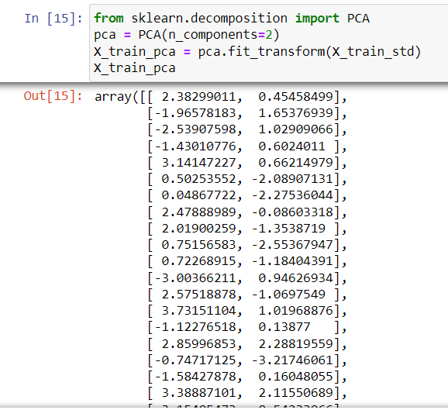

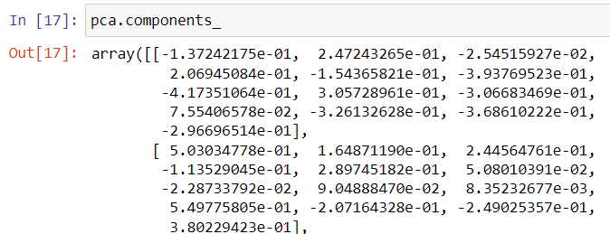

1. In this part, we introduced **Linear Discriminant Analysis (LDA)**, a supervised learning technique used for dimensionality reduction. Unlike Principal Component Analysis (PCA), which is unsupervised and focuses on variance, LDA aims to separate different classes in the dataset as much as possible while reducing dimensions.
2. To implement LDA using the Scikit-learn library, we import the necessary module, initialize the LDA object, and use the fit_transform method with both the training features (X) and target labels (Y). This generates two new features with explained variance ratios of approximately 0.68 and 0.31.
3. Finally, we visualize the transformed data with a plot to see how the reduced dimensions look. The key takeaway is that LDA considers the target variable while reducing dimensions, making it distinct from PCA.



